FHIMS WG Terminology Modeling Sub-Project Meeting

Summary of Call

Date/time of call: Wednesday, September 2, 2015, 2:00 – 3:30 PM

|  |  |  |  |
| --- | --- | --- | --- |
| **Attendees** | | | |
| Jay Lyle - FHA PMO | Y | Robert Crawford – VA |  |
| Rob McClure – ONC/FHA |  | David Bass – VA | Y |
| Bill Hess – FDA | Y | Sean Muir – VA |  |
| Galen Mulrooney - VA/VHA | Y | Ioana Singureanu |  |
| Susan Matney – 3M | Y | Lawrence Callahan – FDA |  |
| Steve Wagner – FHA | Y | Loren Stevenson – VA | Y |
| Holly Miller – VA |  | Russ Leftwich |  |
| Raisa Ionin |  | Bobbi Peterson | Y |
| Kevin Brady – NIST |  | Kathleen Charters |  |
| Tosh Chartner |  | Coco Tsai |  |
| Huma Munir |  | Bo Wang - DoD | Y |
| Nathan Davis |  | Sue Thompson - NCPDP |  |
| Sutai Jiang -- DHA |  | Lynn Sanders | Y |
| Jason Lee |  | Hakan Lidstrom - FHA PMO | Y |
| Liz McCool |  | Teresa Strickland |  |
| Jim Kretz |  | Iona Thraen |  |
| Virginia Saba |  | Luann Whittenburg | Y |
| Daniel Ballard |  | Steve Hufnagel | Y |

Agenda

Review of domain progress

Review of Care Plan status

Review of action items

Review of implementation path (publication, binding)

Resume care plan analysis

Minutes

Domains:

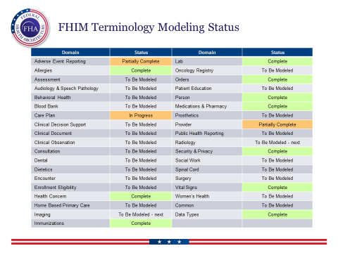

* Domain list based on import of VHIM several years ago. Spinal Cord, e.g., likely to not be part of ultimate FHIM.
* Need to put domain pdfs on web site - first on fhims.org.
* Find a time to look at binding machinery with Sean, Steve, Galen

Using last meeting minutes:

* Care Plan Episode category
  + What are requirements?
    - Security? Some values may have implications (see tags in Security model)
    - Protocol (template) vs personal plan (instance)
      * Question: better name for ‘protocol’? Pathway? Clinical guideline? Care pathway?
      * Protocols are usually procedure or disorder related. But may contain bits from other disciplines.
      * You can use the path to determine whether a patient is in line
        + Monitor cardiac status: ccc or sct; actions loinc.
        + Post partum, any surgery, copd, etc.
    - Episode: one plan (for a disease or other specific period)
      * DoD: care plan is longitudinal, life of patient.
      * Confirmed: FHIM episode is compositional (via inheritance from Clinical Information class)
  + Options for terminology
    - CCC, SOC, Provider taxonomy, CMS place of service, AHA service classification, ICD disease,
    - DB: LOINC, if anything, for VA
    - SM: SCT has a short list under protcols
    - *Check what we find vs. LOINC document ontology
* Care intervention classification
  + sources
    - Could be CCC 21 care components
    - Or LOINC
    - Katz? (ask Virginia) Accepted standard for assessing functional ability. May not be encoded.
    - ICF (<http://apps.who.int/classifications/icfbrowser/>)
  + One intervention may have multiple actions
  + LuAnn & Susan to work on examples for intervention classification
    - Clarify how many levels, purposes & how to name them
* Mail minutes out to list

Next Call

Care Plan

Issues

|  |  |  |
| --- | --- | --- |
| **Issue** | **Status** | **Owner** |
| Stewardship for NCPDP value sets & code systems  JL drafted proposal for NCPDP; RM, SW to take forward | Open | JL, RM, SW |

**Action items**

| Item Description | Responsible Individual | Due Date |
| --- | --- | --- |
| Look into data on actual system usage in NCPDP instances | Sue Thompson |  |
| Discuss stewardship with NCPDP | RM, SW |  |
| Research reactants with IMHC, VA, KP  Naveen Maram, Holly Miller helping | JL |  |
| Research V2 lab coded value frequencies  Tom Oniki helping | JL |  |

**Schedule of Future Meetings**

1) The weekly general Information Modeling (IM) project call is held each Friday from 2:30 to 4:30 PM Eastern Time.

Information for participating in the calls:

Name: FHIMS WG Information Modeling Project Call

Recurring Weekly Call Every Friday

Time of Call: 2:30 to 4:30 PM Eastern Time

Dial-in Information: 1 (773) 897-3018, Access Code: 585-151-437

Web Meeting URL: <https://global.gotomeeti​ng.com/meeting/join/5851​51437>

2) The weekly Terminology Information modeling calls are held on Wednesdays from 2-3:30 PM Eastern Time.

Information for participating in the calls:

Name: FHIMS WG Information Modeling Project Call

Recurring Weekly Call Every Wednesday

Time of Call: 2:00 to 3:30 PM Eastern Time

Dial-in Information: 1 1 (773) 945-1031 Access Code: 849-124-653

Web Meeting URL: https://global.gotomeeti​ng.com/join/849124653